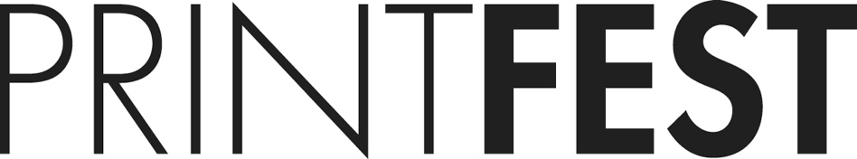

**Become a Friend of Printfest**

**Printfest 2018 Dates:**

**Opening Talk:**

Thursday 3rd May, 6pm

**Friends of Printfest Preview:**

Friday 4th May, 6.30pm onwards

**Private view:**

Friday 4th May, 7-9pm

**Open:**

Saturday 5th May, 10-5pm

Sunday 6th May, 10-4pm.

**Venue:**

Coronations Hall

County Square

Ulverston

Cumbria LA12 7LZ

We welcome **Friends** that share   
our aims and values for the UK's foremost artists-led printmaking festival. Dedicated to the sale of contemporary prints it offers the opportunity to view, purchase art works, meet artists and learn more about printmaking.

**Friends benefits:**  
• Membership card. Your **Friend of Printfest** **membership card** features the 2017 Printmakers’ Printmaker award winner; **Georgina Bown**. You will be able to meet her and see her work at Printfest 2018.  
• A special invitation to the **Friends of Printfest** Preview, which opens at 6.30pm, half an hour before the official opening of the Private Viewing on Friday 4th May 2018.  
• Complimentary ticket to the Thursday evening Opening Talk by Printmaker of the Year Gail Brodholt and Printmakers’ Printmaker Georgina Bown. (Booking essential).  
• Complimentary catalogue.  
• Complimentary glass of wine.  
• Your name on the Friends page of the catalogue and the website to acknowledge your support.  
• Opportunity to re-visit during open hours, throughout the Printfest weekend.



www.printfest.uk

@printfestnews

Printfest-Ulverston

printfestulverston

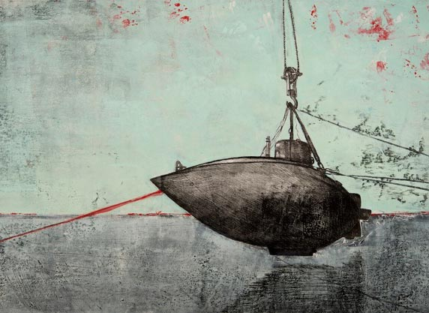

**How to become a Friend of Printfest ~ Application Form**

Membership costs just **£20 for indviduals, £25 for couples and £100 for corporates**. Your contribution and your support help to sustain Printfest and are very gratefully received. Thank you.

**Choose how to pay:**

Membership fee to be paid to: Ulverston Printfest

Barclays | Sort code: 20-04-68 | Account No: 83930629

**Standing order**

Set up a Standing Order on your bank account to pay annually.

**BACS**

Make a one-off payment through a BACS transfer.

**Credit/Debit card**

Phone 01229716959 to make your payment.   
Printfest uses SumUp Virtual Terminal. [www.sumup.co.uk/](http://www.sumup.co.uk/)

**PayPal**

Go to[**www.printfest.uk/support/friends-of-printfest**](http://printfest.uk/support/friends-of-printfest), click on the PayPal button and follow the PayPal instructions.

**Cheque**  
Fill in your name, postal address and email address below, print out this form and post with your cheque made payable to:  
Ulverston Printfest   
Duddon Lodge, Duddon Bridge,   
Broughton-in-Furness, Cumbria LA20 6EU

**I would like to Become a Friend of Printfest**

Name:

Address:

Email:

If you have any questions, please email [printfest@gmail.com](mailto:printfest@gmail.com?subject=Please%20send%20me%20Printfest%20BACS%20details&body=I%20would%20like%20to%20purchase%20Friend%20of%20Printfest%20membership%2C%20please%20send%20me%20Printfest%20BACS%20detail%20so%20I%20can%20pay%20on-line%0AThank%20you)